MINUTES OF DOZIE OWERRI ASSOCIATION, ABUJA BRANCH GENERAL MEETING HELD ON SATURDAY, 24TH May, 2025.
//Hosts: Dr. Megwa, Dr. Emeana, & The Association. //Venue: House 1A Dodoma Street, Wuse Zone 6
Meeting started at 5:45pm with a call to order by the Vice President. Opening prayers was led by //Mr. Iwuamadi.

//Attendance List:

- Rogers Nwoke 08065129358 July
- Barr. Kelechi Ndukuba 08037156585 September 15
- Mr. Lucky Opara 08035229636 February 14
- Mr. Oliver Akuta 08033218495 September
- Ms. Gloria Okara 08033145888 August 25
- Mr. Malachy Onyeukwu 07030986599 May
- Dr. Tony Okereafor 08033411059 October 1
- Mr. Kris Ohale 08033051296 august
- Mrs. Lizzy Ihezue-Iwuamadi 08059618778 September
- Mrs. Chioma Njoku 08033170084 September
- Ms. Hulda Uba Nkwocha 08036258600 September
- Pastor Iyke Onuoha 08036457841 January 8
- Barr. Emeka Iwuamadi 08038897109 October 2
- Mr. Victor Emeana 08033054474 December 23
- Ms Eucheria Ekeh 08060126404 August 16
- Mr. Paul Ohuche 08034966758 November 25
- Mr. Aristotle John-Emezi 08063266551 March 25
- Mrs. Chidinma Henshaw 08033131177 August 31
- Mr. Aikay Oparah 08038702002 October 2
- Mr. James Ekeji 08033614703
//INTRODUCTION OF NEW ATTENDEES: Mr. Ekeji having successfully completed his probationary period was admitted as a member subject to fulfilment of his financial obligations.

- Dr. Ikechukwu Obihara from Ulakwo, Ngor Okpala. His 1st time of attending the meeting as an observer and wishes to become a registered member of the Association.

The President requested that the Provost and Pastor Ike Onuoha formally welcome the new attendee to the meeting; educate him about the Dozie Owerri Association; and the requirements and procedure to become a registered member.
Apologies for Absentees: Mr. Reginald Anyanwu;

//President’s Opening Remarks:
In his opening remarks, Mr. President welcomed members to the month’s general meeting which is special; being the first one he would be chairing as the duly elected President of the Association for the next administrative tenure expiring March 2028.
Commented [PO1]:
He emphasised the meeting duration of 3 hours(5pm to 8pm) he solicited members support and cooperation in achieving the timing to ensure we go back home in good time.
//Kolanuts was at this point formally presented by the President on behalf of the April born. Oha Victor Emeana coordinated the blessing of kolanut rites.

READING OF MINUTES: Minutes of the last monthly general meeting held in April, 2025 was read by the General Secretary.

Observations:
a. The President requested that going forward the minutes will be reviewed page by page by attendees present, observations/comments taken and subsequently adopted accordingly. It was unanimously agreed by all.
In the absence of any other observations or corrections, a Motion was moved by Mr. Oliver Akuta to adopt the Minutes read as a working document of the Association Supported by Mrs Ike Opara.

MATTERS ARISING/AGENDA:
Action Items
- Create a Google form to gather information on members' age for the group life insurance policy
- Negotiate with insurance companies on the group life insurance policy details, including the proposed death benefit of 2-million-naira, permanent disability benefit of 1 million naira, and hospitalization benefit of 500,000 naira
- Provide an update on the insurance policy negotiations at the next meeting

- Proposal for Membership Committee and Bylaw Amendments
discusses the need for a true test of character and capacity, mentioning the proposal from Eskom and the membership committee.
Speaker 2 agrees that consecutive three-time membership should be removed, suggesting automatic criteria for membership.
Speaker 2 emphasizes the importance of making membership as open as possible and endorses the idea of automatic criteria.
Speaker 1 thanks Speaker 2 and mentions the need for the membership committee to give their report before any decisions are made

- Discussion on Life Insurance for Members
Speaker 1 introduces the topic of group life insurance for members, mentioning consultations with experts and the need for formal quotes.
Speaker 1 outlines two options: mandatory insurance where the association transfers the risk to an insurance company, or optional insurance where the benefit is an additional entitlement.
Speaker 1 suggests a proposal for a death benefit of 1 million or 2 million naira and a permanent disability benefit of 1 million naira.
Speaker 1 mentions the need to finalize the insurance details by June and to prepare for the next monthly meeting in June.
- Debate on Insurance and Dues
Speaker 10 suggests separating insurance from dues and making insurance voluntary, emphasizing the importance of not using dues to pay for insurance.
Speaker 1 explains the legal requirements for group life insurance and the benefits of transferring the risk to an insurance company.
Speaker 4 aligns with the former president's position, suggesting that insurance should not affect the association's financial capacity.
Speaker 1 discusses the potential motivation for members to pay their dues if insurance is attached as an entitlement.

- Committee Reports and Membership Development
Speaker 1 reports on the bylaw and constitution review committee, mentioning that the chairman, Kelechi, will have a meeting by the first week of June.
Speaker 3 from the membership and development committee outlines their terms of reference, including screening and disciplining members.
Speaker 3 suggests adding categories of membership, such as full members, associate members, and patrons, to expand the association's reach.
Speaker 3 reports on an incident involving a member and a host, and the committee's decision to issue a warning and sanction.
- Proposals for Membership Committee and Bylaw Amendments
Speaker 1 summarizes the membership development committee's recommendations, including eligibility criteria and the need for a clear definition of who should be a member.
Speaker 1 mentions the need for an aggressive drive to reactivate dormant members and increase the average age of members.
Speaker 1 proposes outlawing the practice of "ichimia" and imposing a fine for misconduct.
Speaker 1 discusses the need for a formal process to handle membership transfers and the importance of interviewing new members.
- Finance and Projects Committee Reports
Speaker 1 reports on the finance committee, mentioning the need for a financial report and update on a quarterly basis.
Speaker 3 from the projects and programs committee outlines their plans for government intervention and agricultural projects.
Speaker 3 highlights an intervention by the Abuja Chamber of Commerce and Industry to empower women by formalizing their businesses.
Speaker 3 mentions the need for a platform to gather responses and enthusiasm from members and to address issues related to contributions.
- Website and Secretariat Development
Speaker 8 reports on the need for a website and portal for the association, including features like the mission statement, membership categories, and cultural heritage.
Speaker 8 mentions the importance of generating income through subscriptions and downloads.
Speaker 1 discusses the need for a physical office and the potential for a virtual office with a website and portal.
Speaker 2 emphasizes the importance of a website for documenting and sharing historical essays and narratives.
- Security and Collaboration with Government
Speaker 2 raises the issue of security and the need for collaboration with the government to set up vigilante groups.
Speaker 1 agrees to engage the government to see how the association can collaborate on security issues.
Speaker 1 mentions the importance of not dismissing government initiatives outright and the need to explore ways to work together.
Speaker 2 suggests revisiting a report on security and vigilante groups to see how the association can better address these issues.

Business of the Day:
The President of Mezie Owerri Kaduna branch led his Exco members on a visit to us. They are:

- Mr. George Ike: President.
- Chief Pericles Ishiguzo: Vice President.
- Mr. Johnny Nwankwere: Secretary.
- Mr. Chuka Ike: Member

He traced the birthing and support of his chapter to Dozie Owerri Abuja to which they remain very grateful.

May Host -
- : Sir Malachy Onyeukwu
- : Kelechi Omeni Nzewuihe
- : Reginald Anyanwu
- : Ebuzor Chioma

Unveiling of Exco 3 Year Plan.

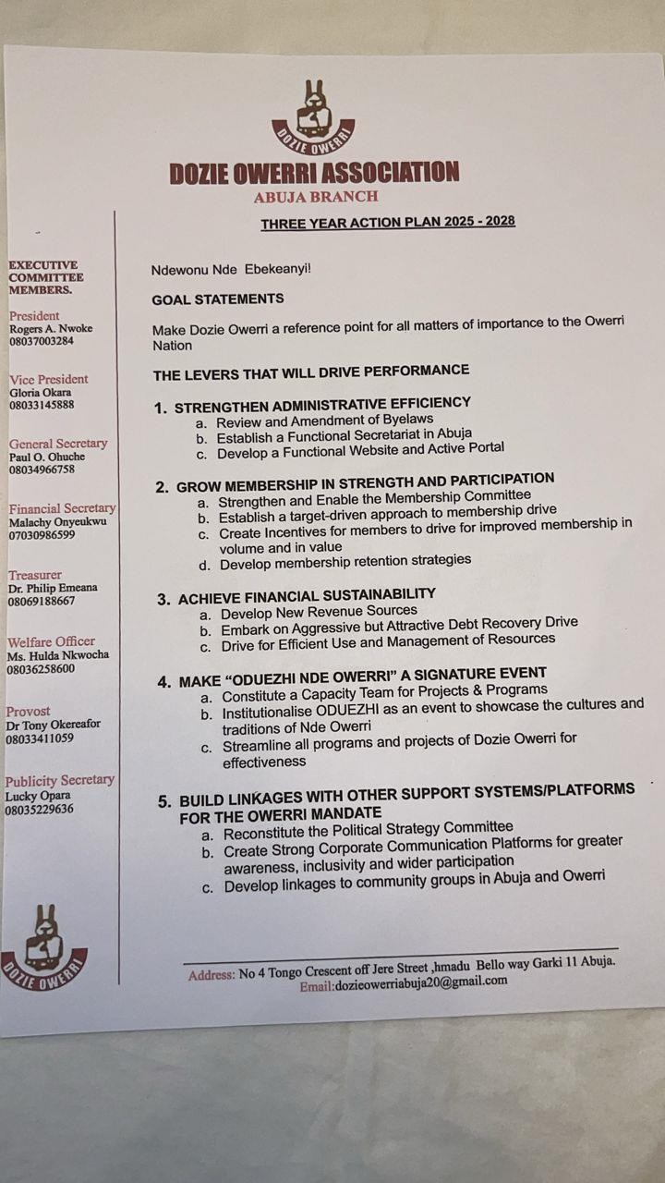

.

Any Other Business //Dues Collected Today:
Prof. Emeribe #30,000
Lucky Opara #5000

Motion for adjournment of the month’s meeting was moved by Sam Amadi, and was supported by Stanley Nkwazema.

Closing prayer was said by Mrs. Lizzy Iwuamadi. Meeting ended at 8:30pm.

………………………… …………………………
Rogers Nwoke Paul Ohuche
President General Secretary

